expresSynth

**An Investigation into the viability of Gestural Control coupled with a Simplistic User Interface as an Alternative Method of Control of a Software Synthesizer.**

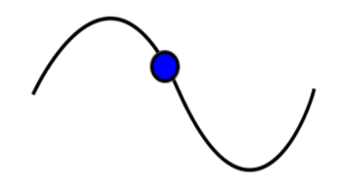

**Tom Holmes**

**Goldsmiths, University of London**

**Department of Computing**

**Abstract.**

**Table of Contents.**

1. **Introduction**
2. **The Problem Posed**
3. **Research**
4. **Implementation**
5. **User Testing and Feedback**
6. **Discussion and Evaluation**
7. **Conclusion**

**1. Introduction**

Despite my love for them, I’ve never not found myself frustrated at the number of controls on most synthesisers. Robert Moog’s original Modular synthesizers have a huge amount of nobs and buttons on them in their most basic form, and depending on configuration, the number could go into the hundreds; Goldsmiths University’s very own Roland 100m Modular has a figure close if not exceeding that number. Even today, in the age of software synthesizers, where the possibilities of intelligent and interesting interfaces are essentially endless due to the very limited programming and design constraints in the digital world, today’s most popular current products, Rob Papen’s Albino and GForce’s Oddity, for example, have if anything increased the number of controls. I can’t help but feel that the dizzying array of controls on most synthesisers is frightening to those who are not familiar - and even those who are - and therefore a lot of people will never try to learn the basics of synthesis, music production or performance using synthesizers, and in the case of more experienced users, may be driven to give up or settle for the sound they have before they can discover the intricate details of sound synthesis using software applications.

The idea for this project is to create a synthesiser that takes away the dazzling on-screen controls and replaces them with gestures, familiar and simple gestures that will hopefully, through research and smart programming and design be intuitive and hopefully breakdown the barrier between confusing user interfaces and fantastically designed sound engines. It is also to develop and clear and concise interface, less cluttered than most of the top synthesizers that are out there today, and also to create a tool that not only acts a tool in production and sound design, but can teach people what the controls are and what they do to sound, while doing so in an enjoyable and straight forward manner. If the control mechanism is a success, there’s no reason that if the project works, the foundation of the gestural control system could be used with other musical or non-musical applications.

I believe that what I am trying to achieve and the techniques required suits the skills that I have learnt while studying and integrates the aspects of software programming, digital signal processing and design that I have found myself both enjoying the most and succeeding at the furthest throughout my three years at Goldsmiths. I have consistently performed well in and enjoyed DSP, particularly in creating and modelling analogue synthesis and sound design, while as a fairly hands-on person, adding a physical aspect to the project in the form of a handheld controller gives me an opportunity to use the skills and thought processes required for physical design and computing and human-computer interaction that wouldn’t be required in a purely software orientated project.

My long term vision is a piece of software that means players can go from a simple starting sound to any sound they can imagine, quicker than is currently possible, and in a way that is more enjoyable, more intuitive and more expressive than is currently possible. The technological world is evolving and developing at a rate that will only increase in the future. The world’s biggest technology companies are now more than ever focusing on improving the relationship between humans and computers, and having taken a programming degree with heavy focus on music and sound, creating a tool that offers a different way of interacting with and controlling musical software is a logical, interesting and fitting project to undertake.

I believe that the current synthesiser user interfaces are both outdated and an obstacle, their cluttered displays are a hindrance to both creativity and expression and I feel sooner rather than later an alternative method of control needs to be developed.

**2. The Problem Posed**

Compared to more commercial applications, mobile telephones, laptops and tablets for example, music production software has fallen behind in the race towards the perfect interface. In 2004 the most modern telephone interfaces were slow, unintuitive, awkward and above all, confusing. We are now in 2017 and the latest iPhone operating system is so familiar and intelligent to use that most people could probably operate them without looking. Unfortunately, the 2004 Logic Pro 7 interface is worrying similar to the current edition. As you can see below, the same can be said for the almost identical Sculpture synthesizer interfaces of 2004 and now, seemingly unchanged despite 13 years of development. Rob Papen’s Albino software synthesizer has barely changed its interface despite three renditions. While many of the world’s essential digital devices have seen constant development, updates and improvements to their design and interface, the same cannot be said for a lot of musical software.

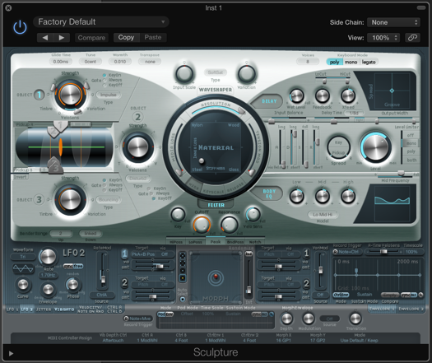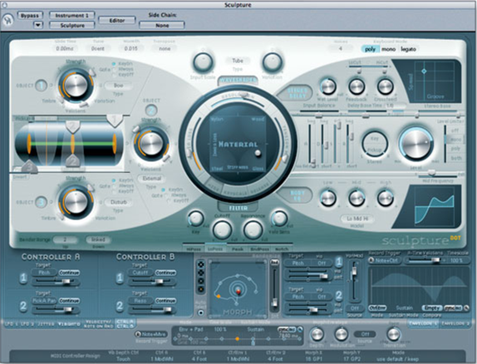

*Logic Pro 7 Sculpture 2004 Logic Pro X Sculpture 2017*

Scrolling down on a phone or laptop used to be the dull process of many button presses, the same could be said for keypresses on a laptop, whereas, nowadays you scroll with a flick of a finger or the touch of a screen. Increasing the pitch, or changing the waveform on a software synthesiser used to be the press of a button, well, it still is. I feel that the rise of gestural control by natural movements found in the latest mainstream technology should be replicated in the soft synth, not only because they would improve the overall feel of the products, but as tools for artistic creation, synthesizers should utilize expressive control if there are methods out there to facilitate it.

My intended approach to this problem is to look into the gestural systems that already exist, both in the musical sphere and outside, in areas such as gaming and television control, and analyse how they work, their successes and failures, and what kind of implementation might realistically work. I intend on building a hardware controller for a piece of software that includes the necessary gesture recognition algorithms along with a comprehensive synthesizer and the accompanying user interface.

Many of the most well-known gestural systems today, such as Microsoft Kinect, utilise computer vision techniques in combination with machine learning to achieve the goals, however in my opinion, despite the advantages of using computer vision system, a hardware controller offers a more achievable alternative given I will be able to choose the components and the respective data they’ll provide, rather than dealing with the unpredictability of a real life scene.

The only consideration I want to have at this stage in terms of intended audience is that the interface is clear, simply and interesting enough that anyone can use it. Whether producers will find it easier or harder, faster or slower to use than standard soft synths or whether someone who performs on a synth would find it easier using a pot or slider on a hardware synth or MIDI controlled soft synth I’m not yet sure!

In order for it to be a product that can be evaluated to a degree where it can be concluded whether or not it is a genuinely viable alternative to the software synths out there today, I intend it to be a prototype, not a finished product, with the focus **not** being on obtaining an impeccably high level of accuracy in gesture recognition, or on a fully accomplished hardware controller, but with all of the aspects and completed and combined to a level where it can be trialled and tested so its intentions and potential are obvious enough to allow a view towards future developments and hopefully a final product.

**3. Research**

There are a number of fields that I needed to consider to ensure I understand why and how products have been successful, or failed in the past and how I might shape the design of all aspects of my project. The areas I’ve looked into are: previously successful examples and my own favourite implementations of software DSP synthesis and sound design, intuitive and creative user interface designs from different software systems, research into the gestures that are found in existing gestural control products to give me an insight into how inventive I can be with the gestures, the physical controller design, and finally the general human-computer interaction and control of gestural systems as a whole to give an idea of historically which systems have worked and which have not.

**3.1 Research into Gestural Systems and Controller Design**

**3.1.1 Method of Control – Handheld or Computer Vision?**

When I first began looking into the gestural systems that are commercially available today, the one that really stood out to me, perhaps unsurprisingly, was the Nintendo Wii. The Wii was, and still is an incredibly successful product, selling 101.63 million units since its 2006 release, with over 30 million units alone shipped in 2008 1. Its design hasn’t changed in almost a decade and its continued popularity and market dominance has meant no similar product has been able to take a significant hold in the gestural game sector. Microsoft’s Kinect camera based add-on for their Xbox range of consoles has sold 24 million units since its release 4 years ago; 4 years after the Wii’s release it had shipped 84 million units.

The key difference between the Wii and the Kinect, and why the Wii stands out to me for this project is that where the Kinect uses Computer Vision, a technique that extracts and interprets data from a camera, essentially imitating the ability of the human eye in the digital world, the Wii uses a less sophisticated method, utilising a physical accelerometer in combination with buttons and infrared communication to send raw acceleration data to its hub, where that data is computed and transformed into on screen reactions.

Computer Vision is fantastic for many applications, and in examples that require object recognition, individual identification, facial recognition or image restoration for example, it is absolutely vital, however, in my opinion, for an application that only requires a few values for movement and speed, a task that could be achieve without the user of a camera, I feel it is too complicated. Using a camera that observes the real world means your data is subject to the randomness and variability of the real world; someone walking past the screen for example, people having different hand sizes, brightness differences due to lighting, or different backgrounds behind the user can cause huge variability in data streams.

There are of course problems with the handheld accelerometer method, the key issue being that different users will inevitably move and hold the controller in different ways, giving variable data that will need to be mapped to the same function. This problem can however be broken down into smaller ones: device orientation, controller speed, gesture size and gesture shape.

Each of these variables can cause gesture recognition to fail if not accounted for, and the combination of more than one unaccounted for could render any kind of mathematical algorithm completely useless, however, when approached individually, the potential impact of each variable component can be fairly easily neutralised.

**3.1.2 Handheld Controller Design**

The Wiimote obviously isn’t the only handheld controller design to consider. Another piece of hardware that has received attention in recent years is mi.mu’s gesture controlled gloves, developed and most notably used by electronic artist Imogen Heap. The glove, like the Wiimote (Nintendo’s official name for the controller part of its Wii system) uses accelerometers and other data sensors that are then manipulated and mapped to different functions. The idea of a glove for music control doesn’t originate from mi.mu’s and Heap’s 2014 glove, one of the original commercially released examples was from Nintendo, who brought out their “Power Glove” in 1989. The Power Glove however was considered a commercial failure, it was too big and uncomfortable for its possibilities4.

Imogen Heap’s glove is still in development stage, 28 years after the release of the Power Glove, showing that this approach to handheld controls is still a long from replicating the commercial viability and success of the Nintendo Wii. My personal opinion on gesture controlled gloves is that they prove too complicated to build and have too much potential to be ugly and uncomfortable. Further, the act of putting on and a taking off a glove can itself alone be quite a prohibitive and obtrusive task.

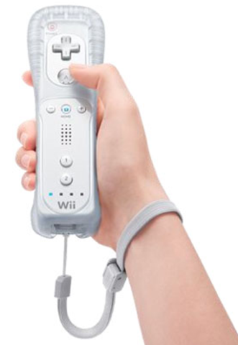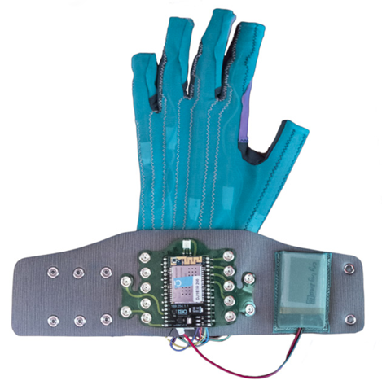

*Imogen Heap’s Mu Glove Nintendo Wiimote*

The design of the controller is very important for a lot of reasons. As Don Norman said in the preface of *The Design of Everyday Things, “the poor design that gives rise to so many of the problems of modern life, especially of modern technology.*” The way the controller is held will influence the orientation of the accelerometer. The amount of edges a controller has decides how many ways it can be held comfortable in hand and therefore the number of potential different orientations. If the user is capable of holding the controller differently at different orientation, every time they how it differently, the values from the accelerometer will change accord to the angle at which it is being held. For controllers that are held with two hands, for example Sony or Microsoft’s PS4 and xBox controllers, molding the controller to the shape of the left and right hand respectively means the controller can only be held comfortably in one way. Now the difference between these controllers and the Wiimote is that they aren’t made to be waved around and as such the Wiimote is only made for single hand usage. The way the combat the problem of constantly changing orientation is, like the Wiimote, to make the controller a square or rectangle with buttons only on the top and bottom. Giving a controller four right angles means that the controller should only fit in the hand comfortable in one way and it cannot move around and change angle in the user’s hand. Having a square or rectangular controller design also gives a reference of the controller’s orientation with respect to the ground.

**3.1.3 Gesture Design and Selection**

Another area that I had to consider, an area which is fundamental to success of any gesture based system, is the design and selection of the gestures. In a more obvious way than the design of the controller itself, the gestures chosen significantly influence whether a user enjoys the product, and whether it feels natural, intuitive and unobtrusive enough to want to use it again. Of course, there is an element of learning to use the system, and therefore an understanding and familiarity of the system built up over time, I believe one of the reasons the Wii is so successful is that you often don’t require an instruction or prompt to know what gesture you need to perform a make something happen, as Nintendo have thought about the command, and chosen the gesture that seems the most obvious and the most natural. Although there is a difference between how naturally the action of changing the release on an envelope with come to you when compared with hitting a golf ball or swinging a tennis racquet, if the gestures were chosen carefully and the user had the chance to learn the gestures, I see no reasons why operating a digital, software synth using gesture couldn’t feel as natural as playing digital golf with gesture.

I began to look at the gestures included in the Wii and Kinect systems as well as others, and the physical equivalent of what they are instructing, so I could then establish what kind of shapes might feel natural and memorable for certain controls of a software synthesizer.

Samsung’s Gestural TV Control Interface uses a wave to wake up the television, I feel this is fairly fitting and obvious, and also feels very natural. It also utilizes a grab for when you want to select something on the screen. The interface also incorporates swipe left and swipe right for moving back a page and forward a page respectively, a very common gesture across a lot of platforms, Apple’s iPhone Interface and Macbook Trackpads, as well as most smartphone interfaces utilize this function for moving between pages and screens.

In the Nintendo Wii Sports game, the actions are also just as natural; in the boxing game you jab forward to punch, in the Tennis game you stroke either with your hand in front of you or behind and in bowling you swing underarm, as you would in the real world.

Given how close to their real-life equivalents these actions seem, I concluded the best way to establish which gestures suit which commands most appropriately was to ask a selection of friends to “draw” a command, or word, as it came to their head.

I asked three of my course mates and one individual outside of the course who I knew had never used a synthesizer before so get an understand of the thought processes of people who will both understand the commands and those who have no idea what most of the commands mean. The command/words I chose were Sinewave, Triangle, FX, Tremolo, Increase Speed and Add and Subtract. The results were as follows:

**Sinewave** **–** Fortunately, and to great relief, each of my three course mates as well as the other individual drew a sinewave, from left to right.

**Triangle** **–** Again, as expected everyone drew an equilateral triangle, however the start points did differ between the bottom left and bottom right corners and the top of the triangle.

**FX** **–** 2 of the 4 individuals drew an X, starting from the top left, with one moving from the bottom of the first line upwards to the top of the second line and down from there, while the second moved along the bottom of the shape from the end of the first to the bottom of the second line.

**Tremolo** **–** The overall response to tremolo was to move the controller up and down repeated, some quicker and some slower. The individual who didn’t know what tremolo was, moved it in circles repeatedly.

**Increase** **Speed** **–** Aggressive movements upwards and also horizontally to the right.

**Add** **–** Again, fast movements upwards and to the right.

**Subtract** **–** The opposite of increase and add, fast movements downwards and left.

I was quite pleased with the outcome of the experiment as the gestures performed by most of my test subjects were on the whole very similar to what I had thought of myself, thus allowing me to conclude that, at least for people who have used synthesizers before, their ideas of what gestures might be appropriate for particular commands and controls are fairly similar.

There were unsurprisingly variations in the speed and size of the gestures “drawn”, as well as difference in the number of repetitions in shapes like a sinewave where one individual drew up and down three times while another drew down and up just once, the shape was however almost identical.

Another interesting observation from the experiments was that I hadn’t yet considered dexterity and its potential implications; one of the testers was left handed and unsurprisingly he drew all of the shapes with his left hand not his right, interesting.

Following on from the initial gesture experiments I decided to mock up some images and ask again what shapes they thought they should draw. I further expanded these to Gifs that showed when a button might need to be pressed and let go at the beginning (see below, they’re aren’t moving below but when in Gif form they do!). The results of showing these visual commands to people were very good, with everyone performing the gesture as I had expected and as it was drawn in the shape.

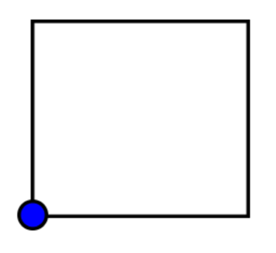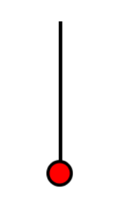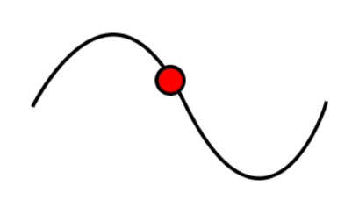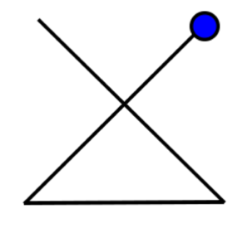

**3.1.4 Possible Number of Gestures**

The problem I am trying to combat with this project is user interfaces with tens, if not hundreds of controls. This number could be brought down using improved interface design and better parameter selection, however as am I looking to use either Machine Learning techniques or a differencing algorithm, and given the already apparent difficulties in obtaining accurate gesture recognition using these techniques, bringing this number down to a number that I can realistically consider differentiating between will be difficult.

I looked into existing gestural systems to see how many gestures they use to gauge an idea of how many gestures I could realistically consider using:

***Microsoft Kinect –*** *Four main gestures: Wave, Guide (in four directions), Scroll and Hover.*

***Samsung’s Gestural TV Interface –*** *Twelve gestures: Wave, Move, Grab, Long Grab, Grab and Move, Thumbs Up, Two Hand Wave, Two Hand Grab & Narrow, Two Hand Grab & Widen, Two Hand Grab & Rotate, Flip Left and Flip Right[8].*

***Wii –*** *No gesture recognition, but acceleration recognition on the X, Y and Z axes, the Wii uses buttons as selection mechanisms.*

***Apple iPhone Touch Screen and Macbook/iMac Trackpads –*** *An incredible 15 different gestures (Trackpad only, iPhone interface is less due to its inability to detect more than one press at a time)[7].*

As you can see, other than Apple’s implementation on their Macbook and iMac Trackpads the highest number there is twelve, while the Nintendo Wii does facilitate any gesture recognizing actions, just control movements and buttons. From this, and depending on what method I use to distinguish between the maximum number of gestures I presume I can use is between 4 and 6. Therefore I will need to use certain gestures more than once to be able to achieve the level of control I need to achieve to make a comprehensive synthesizer. The other major advantage I identified in the Wiimote is that it uses two buttons to essentially double the amount of gestures you can perform. In Wii boxing “jabbing” forward with the remote while pressing the A button on the top produces a different result, this time an uppercut, then if you perform the same gesture while pressing the B button found on the bottom of the controller.

Going by this research, I know I will need to split the gestures into control and selection gestures. Selecting which type of waveform you require, one of the controls that will feature in the synthesizer, is a selection with a discrete number of possible outcomes, increasing the pitch or phase of that oscillator is continuous with a numerical result. The responsiveness of these gestures is also something that needs to be considered when moving between actions with continuous and discrete outcomes. Regardless of what method I chose to recognize the gestures, be it the Euclidean distance or a Hidden Markov Model, it will require analysis and comparison, something that can only occur at the end of a shape. If you want to increase the speed of an LFO, it would feel more natural if the change in speed occurred in unison with the change in acceleration of the controller, and thus the time taken to wait for that gesture to finish and then be compared with whatever database, may detract from how natural the gestural control feels.

**3.2 Research into User Interfaces**

**3.2.1 Overall Design and Style**

The main aim of my project is to find an alternative to the cluttered and confusing user interfaces that are found on many of today’s most popular software synths. Graphical User Interface design and Human Computer Interaction are two huge topics of research and the quality of implementation on products, be it mobile phones, ATM’s, desktop computer applications or anything else is key to their success.

Apple’s design principles cite clarity, deference and depth as the three primary themes that differentiate their iOS design from other platforms 4. For clarity they further explain that text is legible at every size, negative space, color, fonts, graphics and interface elements subtly highlight important content, while for depth they say that distinct visual layers convey hierarchy, impart vitality and facilitate understanding 4.

The reason I cite Apple’s design principles is that as an Apple product user I feel their UI design is fantastically clear and understandable, and the above principles, if followed correctly and cleverly should lead to a successful and clear interface. Of the example soft synths I pointed out earlier, in the case of most, Rob Papen’s Albino, G-Force’s Oddity and funnily enough Apple’s Sculpture, and also many hardware alternatives, in particular the Roland 100m, Apple’s design principles are not followed in their user interfaces. The principle that stands out to me the most is layers. Almost all software synthesizers use only one layer and cram all of the controls into that one space. There are very few examples where a menu is available and you can delve in and out of the oscillator or filter sections for example, with that section filling the screen, allowing clear presentation of the available controls. Manipulating virtual knobs and sliders on a screen with a mouse or even with a multi-touch tablet is awkward. While the ‘virtual hardware’ look may be appealing, it’s too fiddly to perform with5, let alone if all of the synths controls are squashed into an 800x600 pixel space.

Regardless of what gestures I end up using, they need to be explained in a way that is unambiguous and clear. The depiction of each gesture and the way that depiction is interpreted is of paramount important to the success of the program. Nintendo and Microsoft both utilize simple, cartoon-like animations to show what action the user must perform. Other programs use real-life video clips while some others use worded descriptions. Given the resounding success of the Wii and Kinect platforms the obvious choice for me to use is the cartoon animations. User interfaces are often based on static presentations, a model ill-suited for conveying change. Consequently, events on the screen frequently startle and confine users. Cartoon animation, in constant is exceedingly successful at engaging its audience; even the most bizarre events are easily comprehended6. Cartoon animations, although they can be as intricate and elaborate as you wish, are most commonly fairly simple, including only the details essential to depicting what they require. This cartoon-like, simple, unobtrusive design is therefore the route that I feel would best suit my UI design. Stylistically I feel a UI with cartoon animations is more fun than the serious dark and metallic designs found on most of today’s soft synths.

**3.3 Research into Synth Design and Parameter Selection**

As much as I want this to project to find a new way of controlling a synthesizer, I also want the synthesizer to be a comprehensive and satisfying tool for music production. Through my own use of synthesizers along with some examples that have stood the test of time, the Minimoog for example, I think you can deduce a certain number of features you need to have a synth that can make an array of sounds extensive enough for please most users.

The two synths that I want to design my synth around are the before mentioned Minimoog and also the Roland Jupiter-6. Both of these synthesizers have two Voltage Controller Oscillators, one Voltage Controlled Filter, a single LFO and two Envelopes and develop a wide array of sounds from fairly few controls. Given there are restrictions on the number of parameters that can be used due to the confine of gesture differentiating, as well as the desire to keep the interface clean and concise, these two synthesizers, with their wide array of sounds and relatively small number of controls provide a sound starting point for parameter selection.

The Minimoog is a prime example of where less controls can lead to an enhanced experience, the fixed synthesis method of the Minimoog closed down sonic possibilities but also made the process much less daunting for musicians. The way this was laid out on the Minimoog has become the default design workflow for synthesizers both in hardware and software[9]. It is a synth that has featured of countless hit records since the 1970’s with its distinctive filter sweeps, LFO and monophonic sounds. However, despite my admiration for the Minimoog, the reason why problem of cluttered interfaces exists is because not everyone is satisfied with simplicity of the Minimoog.

**4. Implementation**

In this section I will detail and explain how I brought together the initial ideas and desires that I had for this project and the research that I conducted, with the influences that the research had on my decisions in building the software and its accompanying hardware controller.

I had to use a number of technologies and processes to achieve the task, with the technologies and processes changing over the course of the project to overcome the problems and constraints that I encountered.

Having spent the majority of my time at Goldsmiths learning and improving my skills in C++, much of the time using the openFrameworks libraries and its affiliated addons, using openFrameworks was the obvious choice of language to complete the bulk of the programming.

**4.1 Initial Controller Design and Build**

All of my research pointed towards the Nintendo Wiimote as a platform around which to design my controller. The Wiimote’s shape helps to eliminate variability in orientation while its accelerometer driven data capture and infrared connection allow free movement and a stream of simple X, Y, Z values for manipulation.

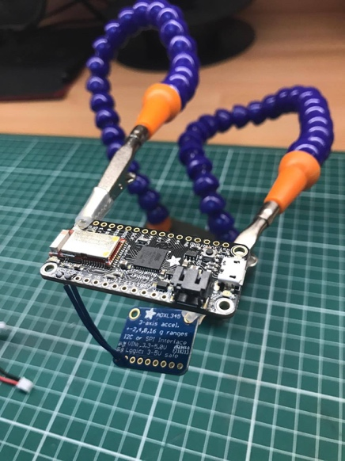I chose to use an ADXL345 Accelerometer along with an Adafruit Bluefruit Feather 32u4 development as a starting point for my controller. The Wiimote features an almost identical ADXL330 Accelerometer that also gives X, Y, Z acceleration values. The Wiimote also incorporates a gyroscope and magnetometer, however looking ahead I didn’t see that these features were essential. If it became apparent a gyroscope and/or magnetometer would significantly help the project, then I could add them later on. The Adafruit Feather offers ample inputs and outputs as well as a Bluetooth Low Energy Module for wireless connection.

Given I wasn’t certain about buttons, haptics or other connections to the controller I left it as it was, with the ADXL345 connected to the Adafruit via the SCL and SDA connections, giving me enough to start analyzing the data input and creating the software necessary for gesture recognition.

The ADXL345 offers 4 acceleration sensitivity settings and the ability to change the data rate. The sensitivity options are 2G, 4G, 8G and 16G, while the available data rates range from 0.1Hz to 3200Hz. I initially chose 2G sensitivity and 50Hz data rate; selecting 2G was arbitrary, subject to later experimentation, while 50Hz was due to Adafruit’s note that rates above 100 Hz will exhibit increased noise. Rates below 6.25 Hz will be more sensitive to temperature variations.[10]

**4.2 Connection and Data Stream**

The first problem to overcome was passing the accelerometer data from the Adafruit into openFrameworks. One of the biggest problems I had with the project was incorporating Bluetooth LE into it and getting the controller to communicate and send data wirelessly.

Apple’s Core Bluetooth documentation and Adafruit’s Bluefruit examples both contain Heart Rate Monitor examples. Having studied the code for both, I learnt about the relationship between Central Managers and Peripherals and how to use UUIDs to identify individual characteristics. I got the Heart Rate Monitor example to function properly, changed the data the Adafruit was sending to the X, Y and Z values from the accelerometer and was able to pick up these values in the Heart Rate Monitor example, albeit in a somewhat ‘laggy’ fashion (something that when I realized the amount of data being sent when playing music over a Bluetooth speaker system baffled me slightly).

Despite these initial successes, my inexperience in the Objective-C language meant that after a couple of weeks of switching around the code and changing the UUID’s, baud rate, etc., I was still unable to transfer the accelerometer data into my openFrameworks applications, and I ultimately decided to move to a serial, wired connection for the time being. This is one of the areas I would like to focus on the most once the project is finished, particularly given what I had said earlier about the “magic” of appearing to control a computer with just your hand, and the obvious damage having a thick, black USB cable in between your hand and computer does to that illusion.

The Arduino IDE that the Adafruit is designed to be programmed on, as well as the openFrameworks main library both have built in serial communication functions. After some issues and confusion with how the Arduino IDE and OF functions send and receive information in byte sizes and formats I was able to get a stream of X, Y and Z values into my OF application using the following code.

Arduino Code:

Serial.print(xAccel, 4);

Serial.print(" ");

Serial.print(zAccel, 4);

Serial.println(" ");

OF Code:

for(int i = 0; i < bufferSz; i++) {

// Fill up the buffer with the incoming characters

buffer[i] = (char)adafruitOne.readByte();

// Split the incoming data into parts, namely X acceleration, Y acceleration and 1 or 0 for blue and red button on/off

xBuf = strtof(buffer, &pEnd);

yBuf = strtof(pEnd, &pEndTwo);

blueBuff = strtof(pEndTwo, &pEndThree);

redBuff = strtof(pEndThree, NULL);

}

Having visualized the gestures that I would use, and determining them to all be 2D, I decided against bringing the Z values in, as these values would not be a principle component in identifying gestures and would simply introduce unnecessary variance and increased complexity in calculations.

**4.3 Initial Gesture Selection**

Following on from the research and tests I had conducted, all of which pointed to simply thinking of the most natural looking and sounding gestures, I drew a diagram (referred to from now on as the ***Gesture Tree***!) that depicted the overall structure of the program, breaking it down into sections, along with 11 two dimensional gestures that I had chosen given what they were controlling or selecting and also a rough estimate of their “closeness” based on the expected acceleration values that might come out from those shapes, given the directions they move.

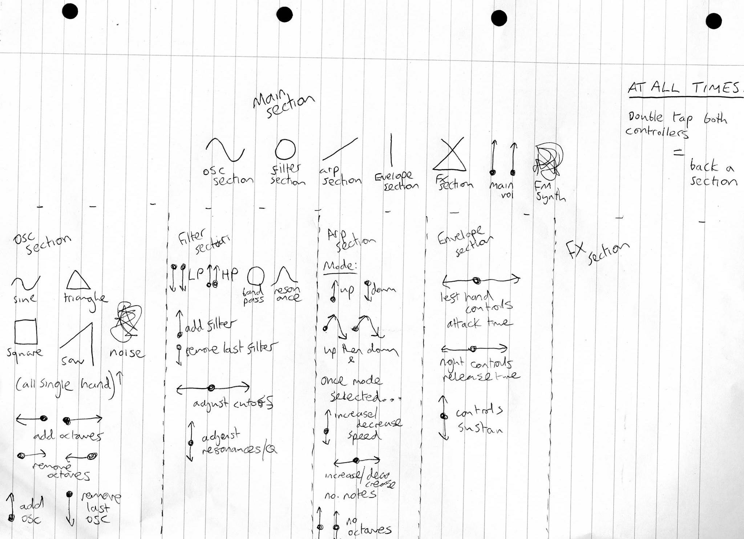

**4.4 Gesture Recognition Method and Data Calibration, Normalization and Comparison**

At this point I had 11 gestures that I had chosen as a basis upon which to build the gesture recognition system and a stream of X and Y values signifying the up/down and side to side movement of the handheld controller in a 2-dimensional space. To get the movement of the controller transferred into shapes recognized I needed to first calibrate the data, normalize and scale it into a set amount of readings and then compare the data with a pre-recorded set of data for each gesture that had itself been normalized and scaled.

The issue with calibration was that different people may hold the controller differently. As I mentioned earlier the Wiimote overcomes this by using a four sided case that can be held at one of four possible orientations given how the human hand naturally holds such a shape. The Wiimote also has a gyroscope which I assume it uses to calculate which way it is pointing.

Rather than achieving calibration and consistency in orientation between users by asking them to perform a gesture and then mathematically work out how the controller is currently orientated, I decided that creating a controller with a shape that followed the Wiimote’s design would achieve the same results.

**4.4.1 Data Storing**

The C++ vector class offers variable size, dynamic arrays of any data type. After creating and recording sets of data in separate X and Y value arrays I found that I could push back one array with pairs of values. Using the keyPressed and keyReleased methods to trigger the start and stop of recording I was able to perform a gesture with the controller while holding down a key, during which each pair of X and Y acceleration values would be pushed back forming a vector of that gesture.

shape.push_back(make_pair(xAccel, yAccel));

**4.4.2 Normalization**

As the data rate of the Accelerometer is fixed, and the OF application runs at a defined number of times per second, holding down the record key for longer or shorter amounts of time will give different amounts of values in that vector. Given any recognition algorithm will require a standard number of values to compare, normalizing the amount of values that is produced during one record cycle is essential, whether the button be held down for 1 second or 10.

To achieve this, I created a function that will take a vector of any length and using linear interpolation will return a vector of pairs of any desired length, scaling the values appropriately. This essential function eliminates time variance.

vector< pair<float, float> > Gesture::vectorNormalize(vector< pair<float, float> > vectorIn, int amount) {

int vecInSize = vectorIn.size();

vector< pair<float, float> > vecLerp;

vector< pair<float, float> > finalVec;

for(int i = 0; i < (vecInSize-1); i++) {

float lerpXAmt = lerpDifference(vectorIn[i].first, vectorIn[i+1].first, amount);

float lerpYAmt = lerpDifference(vectorIn[i].second, vectorIn[i+1].second, amount);

for(int j = 0; j < amount; j++) {

vecLerp.push_back(make_pair(vectorIn[i].first + (j * lerpXAmt), vectorIn[i].second + (j * lerpYAmt)));

}

}

for(int i = 0; i < vecLerp.size(); i++) {

if(i % (vecInSize-1) == 0) {

finalVec.push_back(make_pair(vecLerp[i].first, vecLerp[i].second));

}

}

return finalVec;

}

For both X and Y values, the function takes the size of the vector that is passed into it, it then takes the number of values you require the vector to be and using an interpolation function creates this amount of new points between each point of the original vector. That creates a vector that is the size of both the original and new vectors multiplied together, i.e. the highest common multiple (granted there will be cases where a lower common multiple is possible, but for complexity purposes and the actually impact on processing time given C++’s capabilities, this will suffice). Now that a vector with the highest common multiple of linearly interpolated pairs of X and Y values is created, the function then proceeds to iterate through every nth pair - n being the number of required pairs - to give a vector of the desired size.

I ran some tests where I would draw each of the different shapes while holding down the record key to see what size vectors were being produced. For shorter shapes, like a vertical line up or line down, the number of value pairs was typically between 35 and 40. For shapes like the saw or sine waves, the number of pairs was slightly higher, between 50 and 60. For slightly increased accuracy I chose 70 as the initial number of values I would convert each recording into for comparison.

**4.4.3 Gesture Recognition Method and Comparison**

The three options I considered for the method of gesture recognition were the machine learning approach of Hidden Markov Models using the ofxHMM addon and the purely mathematic method of calculating the Euclidean distance between the acceleration values, adding them up and the calculating which gesture the recorded one is closest to out of a set of previously recorded gestures.

As the task at hand is relatively simple, I decided that the Euclidean distance method would be the best place to start. For certain applications Machine Learning is much, much better than mathematical methods that don’t employ training improvement algorithms, but like using Computer Vision as compared as an accelerometer over serial, may prove too complicated given the extent of the task I’ve set out to achieve.

**4.4.4 Gesture Recognition Algorithm**

After each of the shape vectors have been recorded and normalized, the following algorithm then calculates and totals the difference between the X values of the recorded shape and each of the reference shapes, and then calculates the same value for each Y value, adding that to the total. This value represents the total Euclidean difference between the recorded vector and each of the reference vectors, finding the minimum of these differences will then give the shape that the recorded shape is closest to.

int Gesture::select() {

for(int i = 0; i < record.size(); i++) {

sineDifference += abs(record[i].first - sine[i].first) + abs(record[i].second - sine[i].second);

triangleDifference += abs(record[i].first - triangle[i].first) + abs(record[i].second - triangle[i].second);

squareDifference += abs(record[i].first - square[i].first) + abs(record[i].second - square[i].second);

sawDifference += abs(record[i].first - saw[i].first) + abs(record[i].second - saw[i].second);

eightDifference += abs(record[i].first - eight[i].first) + abs(record[i].second - eight[i].second);

}

int returnValue = findMinimum(sineDiff, triangleDiff, squareDiff, sawDiff, eightDiff, 3000000000);

return returnValue;

returnValue = 0;

}

**4.5 Testing and Decision of Final Gestures**

Once the algorithms were in place to record, normalize, store and compare gestures, I could begin testing, looking into which shapes are accurately recognized, which shapes were identified incorrectly and which shapes had the biggest and smallest differences from each other. At this point I also needed to consider calibrations and the difference in how people would hold the controller and how they would interpret the shapes they were told to draw.

I created Gifs of each shape that indicated where each gesture would start, where to move and how fast to move the controller. Once this was done I recorded and stored vectors for all 11 gestures I had chosen to compare and wrote the code that would compare each of the 11 stored gesture vectors with an incoming gesture. I then repeated this process for all 11 gestures to give difference readings between all 11 shapes and their own pre-recorded vector.

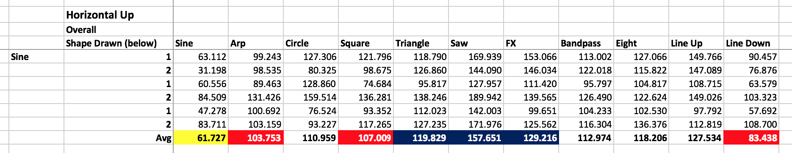

The above table shows the acceleration differences when I performed the sinewave gesture, each column giving the X/Y sum difference between the incoming gesture and each of the recorded gestures. The full table with results for each of the 11 gestures performed can be found on an attached spreadsheet (titled *Testing Spreadsheet*).

The six rows show two attempts for three different calibrations, in order to show how different users and dexterities can affect the difference values and therefore the accuracy of the algorithm. In each of these cases, the 11 pre-recorded shapes were recalibrated by that user. Having tested with my left hand performing the calibrations and my right hand performing the recordings, the results were very inaccurate, showing that person to person recalibration is the only way to use this method of gesture recognition and achieve any reasonable level of accuracy, hence why the recalibrating of the program for each user is an element I will include in the final program

Once I’d averaged the differences for each of the six attempts over three calibrations I looked at the shapes and took the three greatest differences and the three smallest differences to the shape recorded. From this I could take the three shapes with the smallest differences and conclude they could not be used together with the recorded gesture at any point in the program. The three shapes with the greatest could be used together with the recorded gesture as they were shown to be the furthest apart in terms of combined distance difference. From the remaining four shapes I could chose the ones the best suited the selection or control method on the synth that suited best in terms of appearance.

Having made changes to my earlier Gesture Tree to incorporate these results, I ran the tests again, only calculating the differences between shapes that would appear on the same page to see what difference had been made to the accuracy between gestures and what kind of overall accuracy I could achieve. The levels of accuracy were still fairly modest in comparison to what I had hoped for, the algorithm selecting the performed gesture around 65-70% of the time.

Despite the relatively low level of accuracy I decided the best way to improve accuracy would be, like the Wiimote, to add a second button on the controller which could half the the number of gestures I’d need to distinguish between, as some could be performed with one button, others with the other button, and then separate the outcomes based on the button that had been pressed.

**4.6 Final Controller Design and Build**

I now knew the controller would require two buttons, and given the earlier issues with Bluetooth LE connectivity forcing the controller to utilize a serial, wired connection only, I no longer needed space for a battery, but instead needed a port at which you could connect a USB cable. The process of finding a suitable shell for the controller was very hit and miss, but I eventually found a 1960’s Peterson Slide Viewer that was both the right shape and size for the controller. The slide viewer had a removable lid that allowed easy access to the inside, useful for soldering and maintenance once the circuit had been attached. It also had a transparent plastic window at the bottom, originally intended as the viewpoint for the slides, but in my case meant users could see the innards of the device, a nice touch.

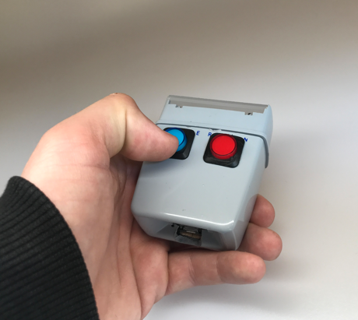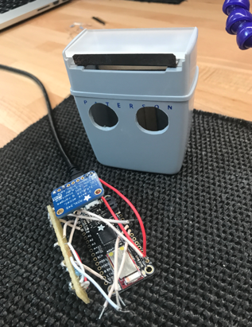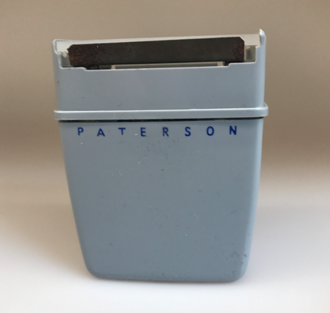

In keeping with the blue and red colour scheme of the software I purchased blue and red LED illuminating 16mm momentary switch push buttons and fitted them just below the meeting of the top and bottom sections.

The circuit itself was very simple. The ADXL345 was connected to the board via the power, ground and SDA and SCL connectors and each button was attached to the power, ground and a digital in pin. The ADXL and board were super-glued to the top and bottom of the inside respectively. Super-gluing the board to the case was necessary as screwing would’ve mean holes through the case, interrupting the smooth outer of the case, and also high strength was needed to ensure the board didn’t detach when the USB cable was inserted.

**4.7 Program Structure and User Interface Implementation**

4**.7.1 Program Structure**

I created the flow chart below that, in keeping with Apple’s design principles separates the different sections of the synthesizer into layers to create hierarchy and depth in the flow of the program. Each of the six main synth sections is broken down into their respective control and selection sections allowing isolation of the gestures that use the gesture recognition algorithm from the gestures that react directly to acceleration. The bi-directional arrows show the movement backwards and forwards through the layers and sections of the synthesizer, once you’ve moved through the instructions and calibration stages the home section acts as the furthest point back in the synth you can go, but from which you can move to any section of the synth in just two steps. Splitting the section into these layers and further into selection and control sections reduces the amount of gestures you need to distinguish between at any point in the program.

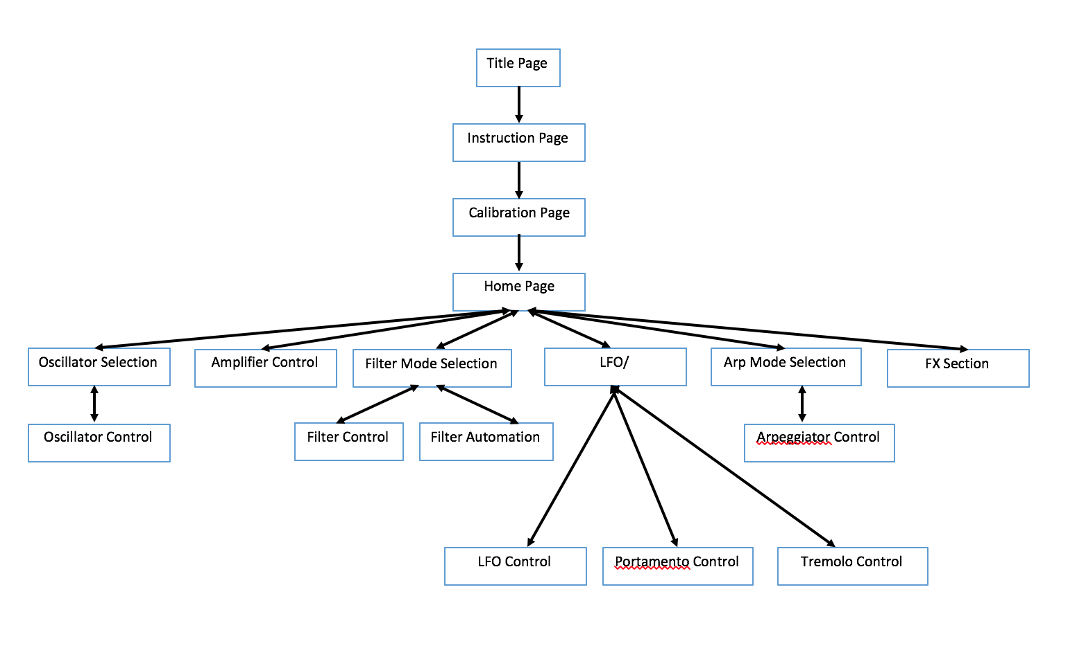

From the flow chart I build the interface of the program, incorporating the animated Gifs and choosing a cartoon font that worked with the minimalistic animations and added a current settings section at the bottom of the screen, written in bitmap font in white writing on a black background so to stand out from the rest of the page. Each of the six sections features a title, its corresponding Gif and a short list of the controls that can be found in that section. Below is a screenshot of the main home section.

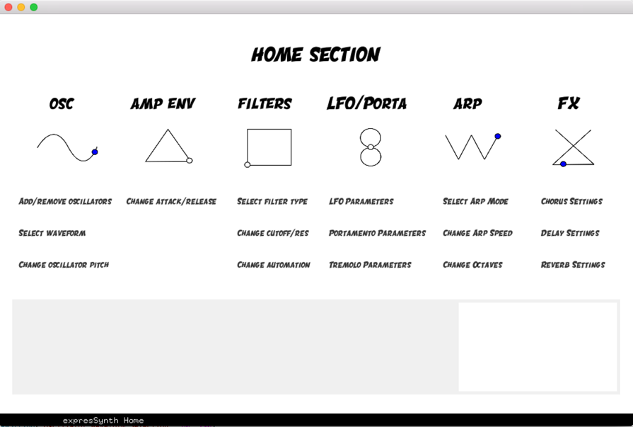

Below is a screenshot of the oscillator selection screen. As you can see, the home section title, as well as the titles and Gifs of the other five now inactive sections are now slightly faded, highlighting the currently active oscillator section Gif and title. The current settings section is in black and white at the bottom and now shows the settings relevant to the oscillator section. As shown in the earlier flow chart, once you’ve selected a waveform you will be taken to oscillator control section. This change from selection to control page is also signified by a change in colour of the ‘OSC’ title from blue to red. These aspects are common to each of the six sections of the synthesizer, the colour change of the title from the selection to control section is the same for all sections as is the fading out of the inactive sections, as is the immediate move from selection to control sections once a selection has been made. Keeping the sections visually and functionally similar but still clear should hopefully allow the users to build a familiarity with the interface and movement around the program, allowing quick changes to the synths parameters and a knowledge of where to go and what section to be in for each particular parameter.

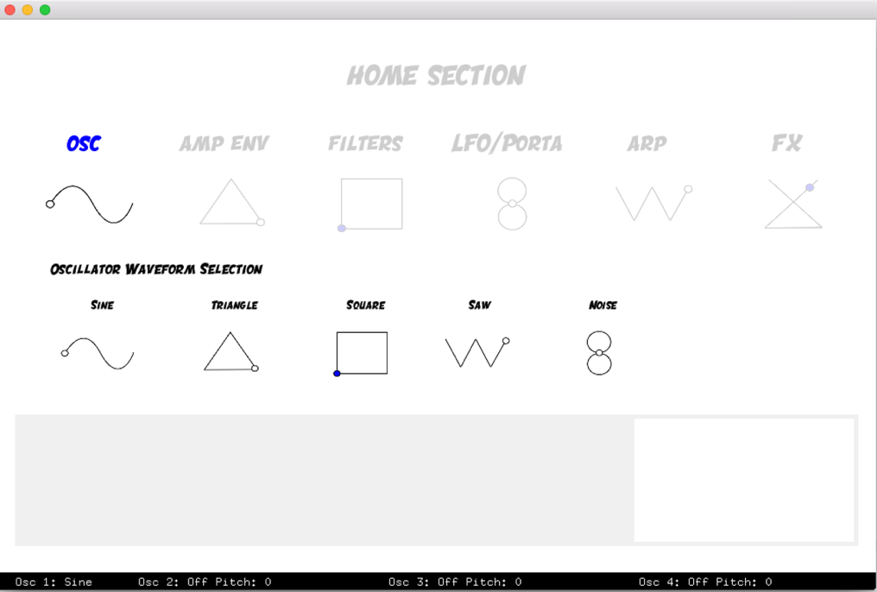

**4.8 Synth Engine Implementation**

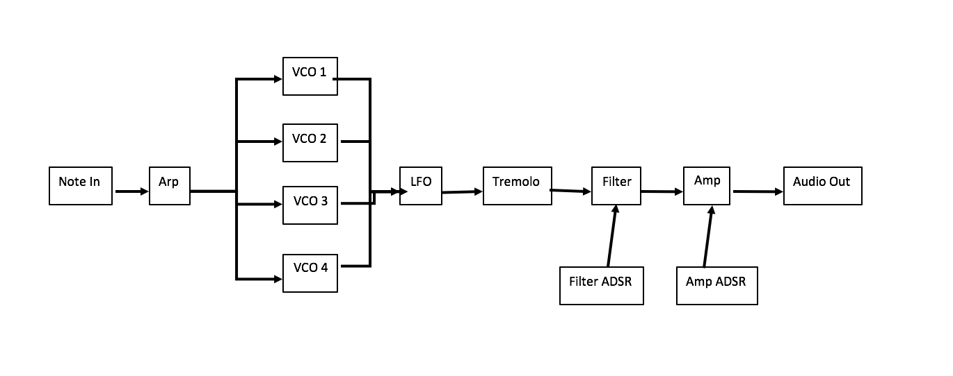Having taken inspiration from the Minimoog and Roland Jupiter and Juno synthesizers I kept the synthesizer engine design fairly simple, using subtractive synthesis along with the controls and parameters needed to allow for a wide range of classic synth sounds. Each of the 12 voices in the synthesizer has four oscillators, each of which can produce a sine, triangle, square, sawtooth or noise wave. These four oscillators are then added together and passed through a low-frequency oscillator, a tremolo, a selectable mode filter with automation, an arpeggiator and finally an amplifier.

The filter is switchable between low-pass, high-pass, resonant low-pass and resonant high-pass modes, with controllable cutoff, resonance and automation featuring attack and release control. The LFO speed was limited to 20Hz to avoid any unwanted frequency modulation interference. The arpeggiator cycles through a pentatonic scale at a selectable speed and features up, down and up-down modes between one and four octaves.

**5. User Testing and Feedback**

**5.1 Questions Posed**

My user testing involved asking five individuals to use the program, offering them minimal help and advice about how to use it and seeing what sounds they could create, how easily they found navigating around the different sections, and noting any difficulties or issues they had with the program.

My test cohort included one experienced producer, three individuals from my course who I knew were familiar with the functions and operations of software and hardware synthesizers and one individual who I knew had never used a synthesizer before. I felt this range of experience and knowledge of synthesizers amongst the test base would provide the most complete and comprehensive feedback, giving an insight into the competencies, qualities and fallbacks of the program from the point of view of those who might have an understanding of how it would work, and those who’ve never seen anything like it before.

The questions asked of the users after testing the synth were focused on the ease of use and clarity of the instructions and commands, the quality, clarity and simplicity of the interface, the shapes of the gestures themselves and if they felt natural, the design of the controller and the overall feel of the synth and its potential applications.

Each of the five individuals were recorded using the synth and a link to the full test video together with their comments and feedback can be found at *https://youtu.be/A6Jg07JgJmA*.

**5.2 Feedback and Comments**

On the whole, and given the reason for this project, I was pleased about the feedback the program received from testing. Testing made clear that technically, the project is far from complete and its usability was slightly inhibited by jerky controls and inaccurate gesture recognition, both of which made smooth operation and quick maneuvering around the program fairly difficult. However, as stated in my introduction, the aim of the project was to see if this method of control of a software synthesizer offered an easier and more interesting alternative to the user interfaces found on most software synthesizers, while also to see what people thought of the idea and method of control itself and the potential applications it could have in the future.

Beginning with the design of the controller itself, feedback was very positive. Praise was given for its simplicity, particularly its modest two button design, the correlation between the colour of the buttons and the colour scheme of the software garnered widespread approval, as did the feel of the buttons itself. On the question of orientation, there were no instructions given at the start of the program as to how the controller should be held, but all bar one of the users held the controller in the same way; in front of them with the side with the buttons parallel to the ground. One user held it at a 45-degree angle upright to the ground.

The interface was also very well received with its simplicity, sectional layout and user friendly design the main focus for that praise. The users found it a nice change from the typical interfaces of soft synths. The animated Gifs were said to be clear and unambiguous, while the cartoon nature of the whole interface seemed to inspire thoughts that the synth might be suitable for educational purposes.

The method of interaction with a software synth was also said to interesting, fun and refreshing., exactly what I was going for. Users commented how it felt like a task or a game to get to different parts of the synth; something that, despite being unintentional and a result of my slightly malfunctioning algorithms and parameter mappings, it seems to be a positive for the program.

When asked if the program, mechanism and system as a whole could potentially offer a replacement for soft synths in the future the answers ranged from an emphatic yes, to a fairly resounding no, to suggestions it might be best used as a performance or educational tool, primarily because of the expressive nature of the control gestures and the cartoon-like design of the interface.

There were also some interesting suggestions as to what features could be added to improve the clarity of the interface and instructions and also to improve the sound design, all of which can be seen in the video documentation.

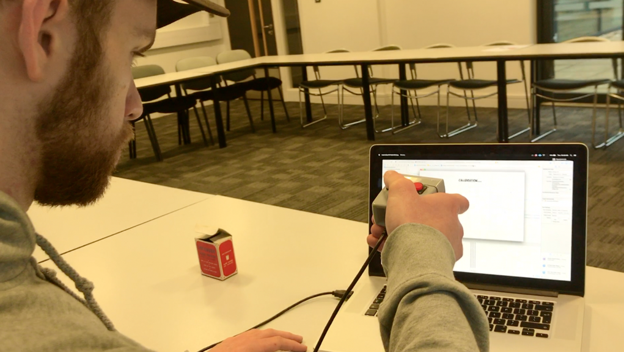

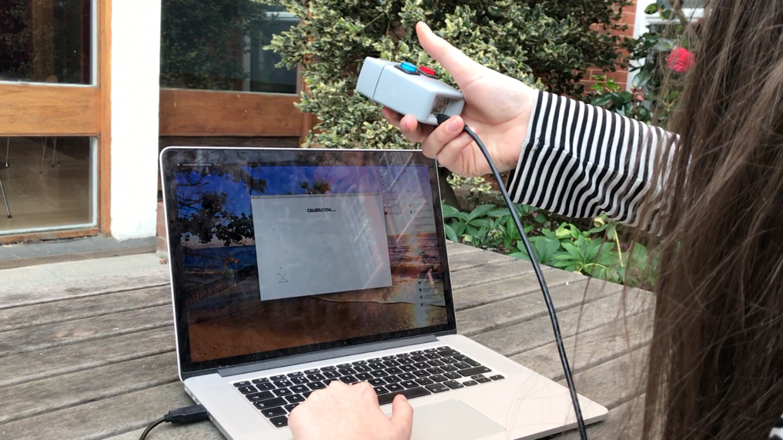

**6. Discussion and Evaluation**

Despite the positive feedback from the user testing, if it did anything, it made clear that the gesture recognition mechanism was nowhere near as good as it should be. Although I stated in my plan that I wasn’t undertaking this project to see how greater level of recognition accuracy I could achieve through experimentation with methods and refining an algorithm, that instead my plan was to build a prototype of a hardware-software hybrid system that included all of the features needed to give an impression of what a final product might resemble, the levels of accuracy I achieved with my mathematical, Euclidean distancing algorithm meant that for the most part, the synthesizer’s feature set couldn’t be fully explored and its method of operation fully analyzed without a fairly annoying amount of time and a good amount of frustration.

I think it was naïve to believe that the Euclidean distancing algorithm alone could achieve what I had set out to do. I my head, I believed that there was no way a vector of paired X and Y acceleration values obtained while drawing a square could be closer in totaled difference to the vector for a prerecorded and stored sinewave then that of a square. However, as I now know, that in attempting to implement a gesture recognition algorithm in the way that I tried, the amount of variables that need to be taken into account and mitigated properly is very high.

The main variables I listed earlier to consider were time variance, difference in the speed that a gesture is drawn, difference in the size of a gesture that’s drawn and the orientation of the controller. Having thought I’d accounted for these variables through various methods, some in interface design and gesture selection, some in code, some in the design of the controller itself, I assumed the Euclidean distancing algorithm would be successful, however as my own and user testing pointed out, humans cannot produce identical gestures time and time again and that if this is not the case the resulting data from the accelerometer can vary dramatically from gesture to gesture. There is also a myriad of other potential problems that I didn’t know needed to be considered, for example if you ask an individual to draw a circle and then draw a sinewave, the next circle you ask them to draw will more often than not been influenced by the size, shape of speed of which they drew the sinewave. This therefore means that throughout the use of the program, and as users inevitably make minor, unintentional alterations to the way they draw their shapes, the gesture recognition slowly becomes more and more inaccurate and unreliable, and as I discovered myself and was clearly apparent during user testing, eventually falls to the point where it may take three or more goes to achieve the desired command, at which point the user feels as though any shape may or may not achieve what they are trying to achieve.

I do therefore feel that in this project would have benefitted huge from the utilization of a machine learning method such as a Hidden Markov Model or Bayesian Mixture Model to realize its full potential, and it is an area that I am very eager to change the method of pattern recognition so in the future, expresSynth can realize its full potential.

However, as I stated earlier, I believed that given the simplicity of the task, I could make the Euclidean method work and although is a minor shame that the algorithm I wrote didn’t perform fantastically, despite these issues, and what I feel is more important, is that my objective for this project was not to create a gesture recognition algorithm that functioned impeccably, it was to put all of the technical pieces of the project together to a standard where the idea of the system could be seen and questions as to its future viability and potential posed, and I feel that this was achieved. As I said, I’m excited to add a Hidden Markov Model or other method to the project in future to take it from a prototype to a finished product in the area of gesture recognition.

On the topic of the control gestures - the functions that directly used the incoming acceleration values coupled with a push of either button - the user testing video shows that at times users struggled to get to grips with the delicacies of the control mechanism. More than once I had to show the appropriate time to release the button on the controller and what type of motion worked best. Without this help, and precisely because the data source is an accelerometer, not a speed detector or something else, the software would not interpret the gesture correctly and the determined change of the parameter was often incorrect, particularly in the cases where the user released the controller after they’d slowed down or stopped, the resulting parameter change would be the opposite of that they intended as the accelerometer was now decelerating.

There are therefore a few changes, alterations and improvements that need to be made in the both the gesture recognition and control algorithms to bring the system to a place where it is truly responsive to the gesture performed and therefore feels natural and intuitive enough to be used fluidly.

Despite the technical problems, I do believe there was undeniable success with the layout, structure and aesthetic of the project; areas that carry the same weight, if not more than the technical success in determining whether or not the project as a whole had been successful, and the question posed has been answered. Each of the test subjects said that they thought the software was clear, understandable and interesting, and it seemed as though was no doubt the method of control, when worked, was more fun that moving a mouse around a screen.

The Gifs received very positive comments with the users unanimously agreeing that the commands they were depicting were obvious and explicit. The user testing did highlight that the interface needs some additions, mainly in terms of instruction at the beginning of the program, for instance how to proceed through the calibration stage and how to go back to the previous section. In response to specific comments from two of the users that the home page particularly was unclear, I’ve added descriptions to that page as to what functions and parameters are included in each of the six sections of the synth.

There were very positive comments about the system wide use of blue and red, from the controller buttons, to the animations, to the change of colour between the selection and control page titles. The current setting section at the bottom of the screen also garnered some positive comments as to how it stood out from the rest of the interface. All of these aspects of the interface, the consistent colour scheme, the sectional layering and the use of negative colours were all inspired by Apple’s design principles and I believe have helped to achieve positive results in areas that are of fundamental importance in creating an interface that is less confusing than other soft synths.

Unfortunately, I was unable to create a Bluetooth LE connection between the controller and the program due to my inexperience with the Objective-C programming language and the requirements and specifications when dealing with Bluetooth LE. Along with improving the gestural recognition this would be an area of high priority when furthering the project as I feel it would add a lot to the overall feeling and appearance of the system were it to be a wireless controller.

Nonetheless, the controller design and build itself was praised for its style and simplicity. A massive stroke of luck lent itself to my finding of a 1960’s slide viewer, an object that fit the hand perfectly and had just enough space for all of the components that would need to go inside the controller. Although I stated that the glove idea championed by Imogen Heap and mi.mu wasn’t very appealing due to its appearance and complexity, after thinking about using expresSynth as a performance tool, the idea of a wearable glove is gaining traction in my head precisely because of its appearance and complexity and the potential that such an idea might have in terms of increased gestures and controls functionality-wise and a sleeker, less visible appearance on the design side.

The biggest question however was whether or not the synthesizer and its hardware controller, as a system, offered a less confusing, more exciting alternative to today’s range of software synthesizers. James Hardy, a regular music producer and the test subject who has the most experience with DAW based music projection didn’t believe, despite thinking the interface was actually clearer than most other soft synths, that the system couldn’t realistically replace today’s MIDI controller and software synth combination, mainly because the speed at which you can control the synth “isn’t as fast as regular soft synths”. Whether improvements to the gesture recognition and control gestures would have changed his mind, I’m not sure but would like to think they would. He did however point out that the project had a lot of potential for use in performance, saying its expressive qualities with the control gestures were interesting both visually and sonically engaging and exciting.

Other users did believe that it offered a realistic and potentially better alternative to what is on offer today, mainly because they felt using a hardware controller as a method of interaction with the computer system and drawing a shape or throwing the controller to the left or right (and not letting go) was a more intuitive and engaging interaction than dragging a mouse around a screen, having to click nobs and sliders. The fact that 3 out of 5 people, without prompting mentioned that it would be good as an educational tool outlines just how simple and easy to understand the interface is, while highlighting that the gestures I’ve chosen to represent certain commands do indeed feel natural and intuitive to the user. I did outline in the beginning the potential for this type of human-computer interaction with software synthesizers as an educational tool, stating that I didn’t think today’s software synthesizer interfaces were conducive to learning and experimentation due to their banal appearance and lack of expression.

It was really pleasing to see that after understanding the basics of how to move around the synth and working out what the different control and selection gestures did only a couple of times, people seemed to genuinely enjoy using the system, particularly on parameters that are very sonically obvious like increasing the cutoff of the filter.

This enjoyment and intrigue when using the system is why I think the idea has a lot of potential. Enjoyment of a creative tool is absolutely fundamental to any positive outcome from exploration of that tool.

**7. Conclusion**

I have thoroughly enjoyed this project. If I had the chance to start again from the beginning, of course I would have done certain things differently, and I would have spent more time working on some parts of the project than others. However, am I pleased with the outcome? Yes, absolutely! Do I think I’ve built a tool that to an extent offers an alternative method of interacting with a software synthesizer? Yes, I think so.

Without a doubt there are some problems that would need to be solved and some glitches fixed if a product like this were to acquire genuine commercial viability, the accuracy of my gesture recognition algorithm being the one that springs to mind the fastest, but on the whole I have combined synthesis design, interface design and program structure, controller design and gesture recognition to a create a product that proves the mundane, cluttered interfaces of most synthesizers are not the only way to interaction and use them. My combination of a simple user interface and selection of relatively simple gestures that as best they can try to represent what synthesizer parameter control gestures would look or feel like has created a method of control that is not only interactive and intuitive, but most importantly enjoyable. Whether its future is as an educational tool, a game, a performance tool or a fully-fledged software synthesizer that can be used for all I’m not sure.

I think the creation and design of the interface was my favourite aspect of the project. It was undeniably satisfying when the system recognised a gesture and changed the waveform, or you flicked the controller to the left or right which in turn shortened or lengthened the amp release, but overall I feel the interface design and program structure implementation are the two stand out aspects of the project.

If I were to undertake a project like this again I would absolutely use a machine learning method, most likely a Hidden Markov Model, to get the gesture recognition accuracy up to a level that it should be. My will to prove that a mathematical algorithm alone could achieve what I set out backfired and slightly hindered the overall success of the project; but we live and we learn! By far the biggest lesson I learnt from this project was that real-life, real-time data is infinitely variable, regardless of how you collect it, be it through a camera or an accelerometer, and taming that data to create symbiosis between a controller and software beyond simple directional movements is a very difficult task, particularly if the right methods aren’t implemented correctly and variant factors aren’t taken into account and mitigated appropriately. However, as I saw when the recognition did work, the result is something fantastic, and a result that I think proves this type of project has a future.

Regarding the future of the project, the feedback from the user testing and the subsequent comments I received from that has left to me to think about a few different ideas and possibilities for the project. One piece of advice I received would be to improve the educational side of the program, perhaps by adding more information in the form of diagrams and text to describe and visualize what each control achieves, something that might help to further solidify the link between the gesture being performed and the parameter it controls. Other suggestions included finding a way to MIDI map the gestures so the shapes and returned MIDI values could control other parameters in a DAW.

**Bibliography**

1 "Wii Sales". *En.wikipedia.org*. N.p., 2017. Web. 7 Apr. 2017.

2 "Wii Remote". *En.wikipedia.org*. N.p., 2017. Web. 7 Apr. 2017.

3 “Gesture Recognition and Interaction with a Glove Controller”, Gerard Llorach Tó, University of Adelaide, Web, July 2013 (http://gerardllorach.weebly.com/uploads/2/6/7/1/26710587/gesturerecognitionandinteractionwithaglovecontroller_gerardllorach.pdf);

4 "Design Principles - Overview - Ios Human Interface Guidelines". *Developer.apple.com*. N.p., 2017. Web. 7 Apr. 2017.

5 Power, Combining et al. "The Strange Agency Isn’T Afraid To Design A Synth With A Mind-Blowing User Interface". Synthtopia. N.p., 2017. Web. 7 Apr. 2017.

6 “Animation: From Cartoons to the User Interface”, Bay-Wei Chang, David Ungar, Web, 7 Arp. 2017.

7 https://developer.apple.com/ios/human-interface-guidelines/overview/design-principles/

8 http://www.samsung.com/ph/smarttv/common/guide_book_3p_si/waving.html

9 http://theconversation.com/sublime-design-the-moog-synthesiser-26460

10 https://learn.adafruit.com/adxl345-digital-accelerometer/library-reference